OnlineBiosensorMCU – Documentation

# How to use the application

After following the devices’ respective installation guide below, this section will help instruct the user on how to use the program. Before starting the program make sure the biosensors are connected to the device. The program is not designed to be detect new connections so make sure the biosensors are connected before the program starts. Similarly, if the biosensor disconnects during the application, it will force stop the program, so take care to prevent this from happening.

Once the application starts, a prompt will appear asking for the modes that the program should be running for each biosensor channel. After selection, the UI will begin to load. If this process hangs for over a few minutes, it is recommended to close the window, un-plug, and re-plug the connected biosensors and try again.

Once the application loads, normal operation begins. Normal operation involves an acquisition cycle then a waiting period which length depends on the time interval parameters. During the acquisition cycle, none of the settings will be changed immediately, rather it will be queued until the acquisition cycle is over before it makes the changes to the settings. This applies to BOD/COD calibration settings changes, graph setting changes, and biosensor parameter changes. It is intended to keep each acquisition reading with the same settings. So do not worry if the settings are changed and nothing appears to have changed visually. It will take a moment for the acquisition cycle to finish.

Regarding LORA functionality, it is checked once upon start-up of the application. If it is enabled, it will attempt to connect to the LORA servers during the loading of the interface. If it fails, LORA will be enabled, and it will not connect until you reset the biosensors and restart application. Otherwise, LORA will be enabled, and it will connect, and all operations will continue as normal. The status bar will help reflect the status of LORA.

# Raspberry Pi Installation Guide

Run the *LinuxOSinstall.sh.command* located in *OnlineBiosensorMCU/Version 1/Installation files/* by double-clicking it. Make sure to execute file in terminal by selecting the “Execute in Terminal” option. (**Once the script is done running it will automatically reboot the Raspberry Pi, so make sure that all work is saved before running the script. The terminal can be closed to cancel the operation).**

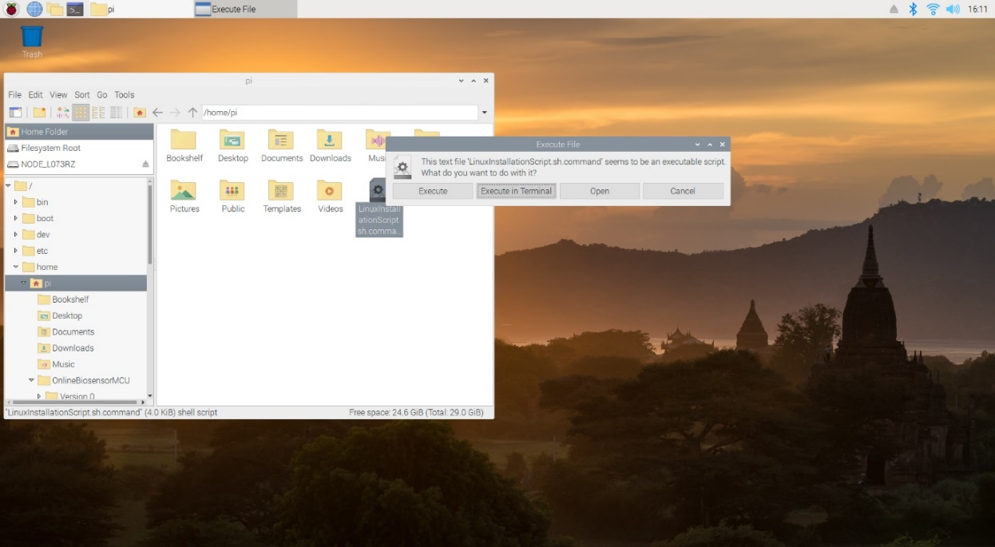

It will open the terminal window and begin installing all the appropriate packages and create the shortcuts. This process will take some time so please wait patiently.

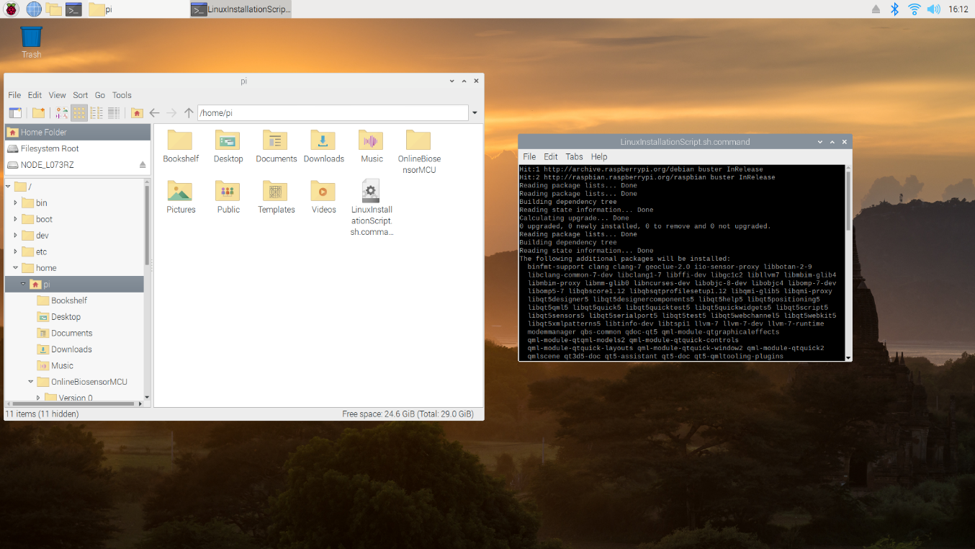

There may be a prompt to enter the github.com credentials to clone the application repository. *(Might not be necessary)*

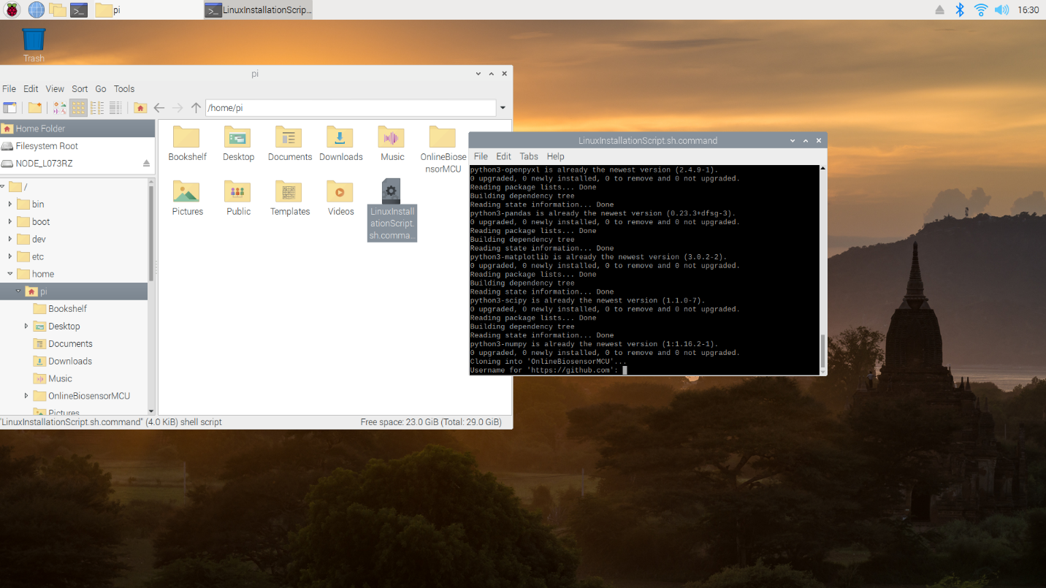

After the script is done running, the Raspberry Pi will automatically reboot. This is what the desktop should look like after reboot. Each folder is for each respective channel’s data.



After a few seconds, the biosensor application will automatically start, and the installation can be confirmed as successful.

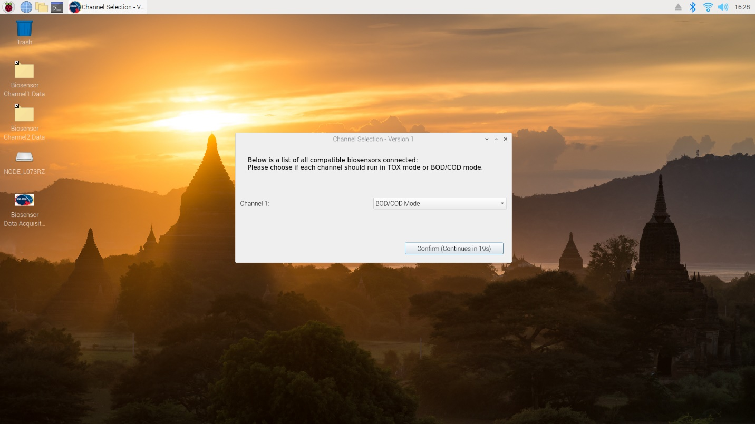

*Important features and quality of life fixes*

* **The application is available in the start menu in the ‘other’ category. If you want to start the application after an accidental close, look there.**
* If the installation fails to install, follow the checklist below:
  + Make sure the installation script is for the most up-to-date version for the application and try again.
  + If this fails, let the developer know.

*For developers of the installation script*

* Usually, installation failures and either be attributed to the following files -> LinuxOSInstallation.sh.command or runBiosensor.sh. If the location of the files is different, then these files must be adjusted accordingly.
* Otherwise, it is most likely due to changes in python packages which caused certain dependencies to be different, or perhaps a certain function has been deprecated. In this situation, try running the installation script on a fresh boot and then testing the code by running the BiosensorMain.py fie via Thonny IDE, and test where it fails.

# Windows Installation Guide

Run the *WOSsetup.exe* located in *OnlineBiosensorMCU/Version 1/Installation files*/ installer file. The file may be placed anywhere, just make sure to remember the location. It will ask the user to execute the file as an administrator so make sure the user’s account has the proper privileges.

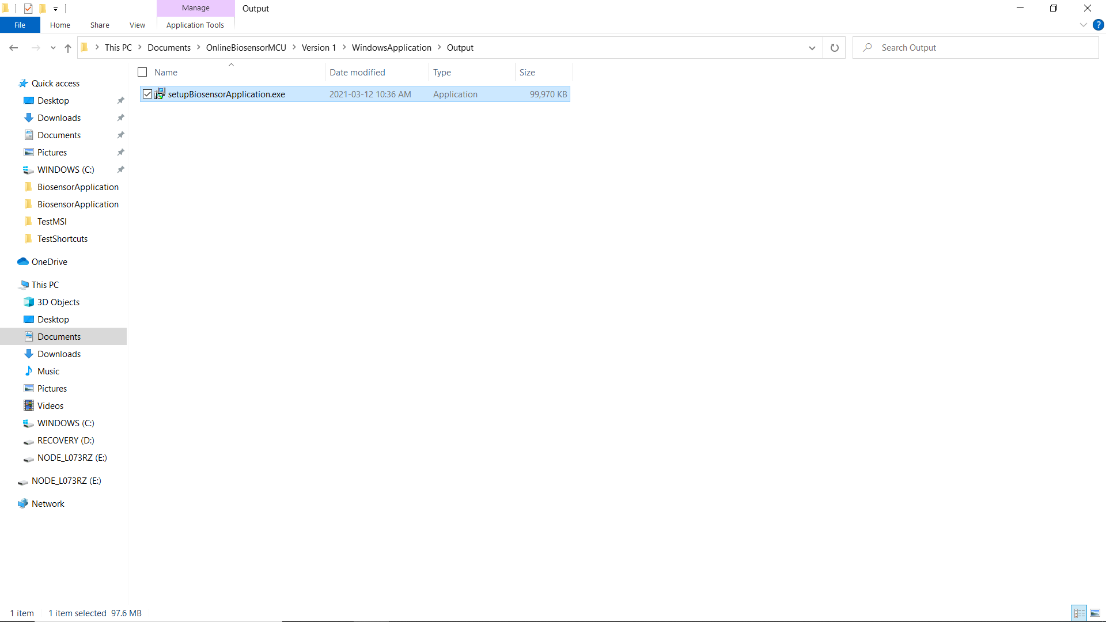

Then the installation language can be selected.

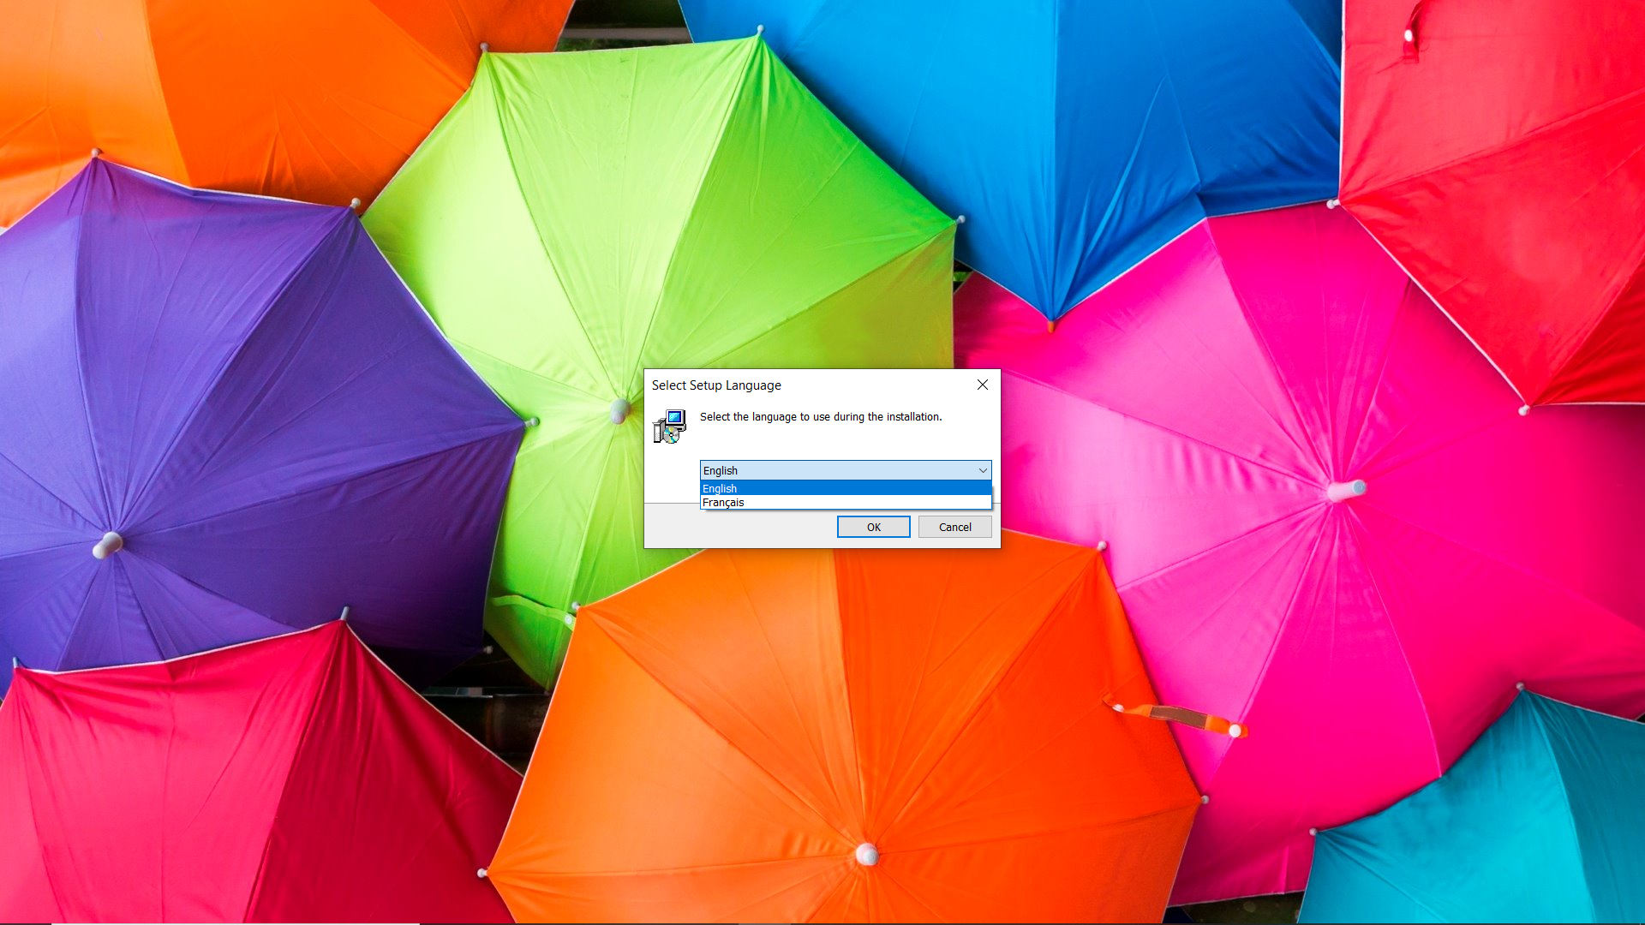

Then the user will be prompted to install the application. **It is advised to not place the application inside the *Program Files* folder or *Program Files (x86)* folder**. **If this is done, every time the application is run, it must be run as an administrator. To do so, right-click the application and select run as administrator.** Other locations will not require this step and are safer to use. (By default, the C drive is selected)

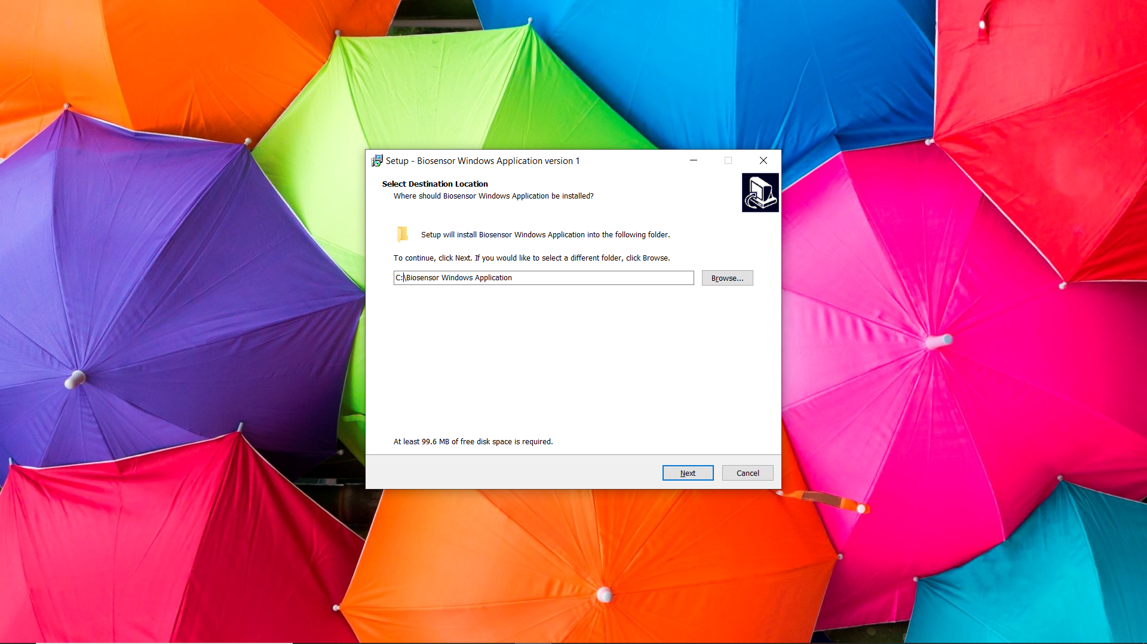

Then the user is prompted to add a shortcut to the program on to the desktop. This step is recommended since the data from acquisitions will be visible on the desktop as well. The application is also visible in the start menu.

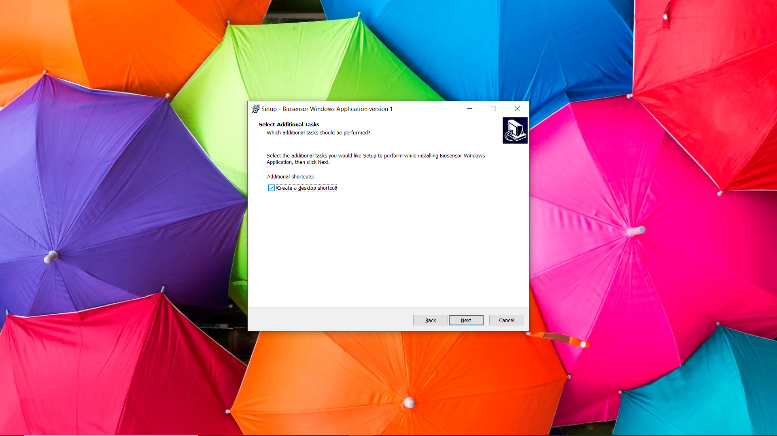

Now the application can be installed. 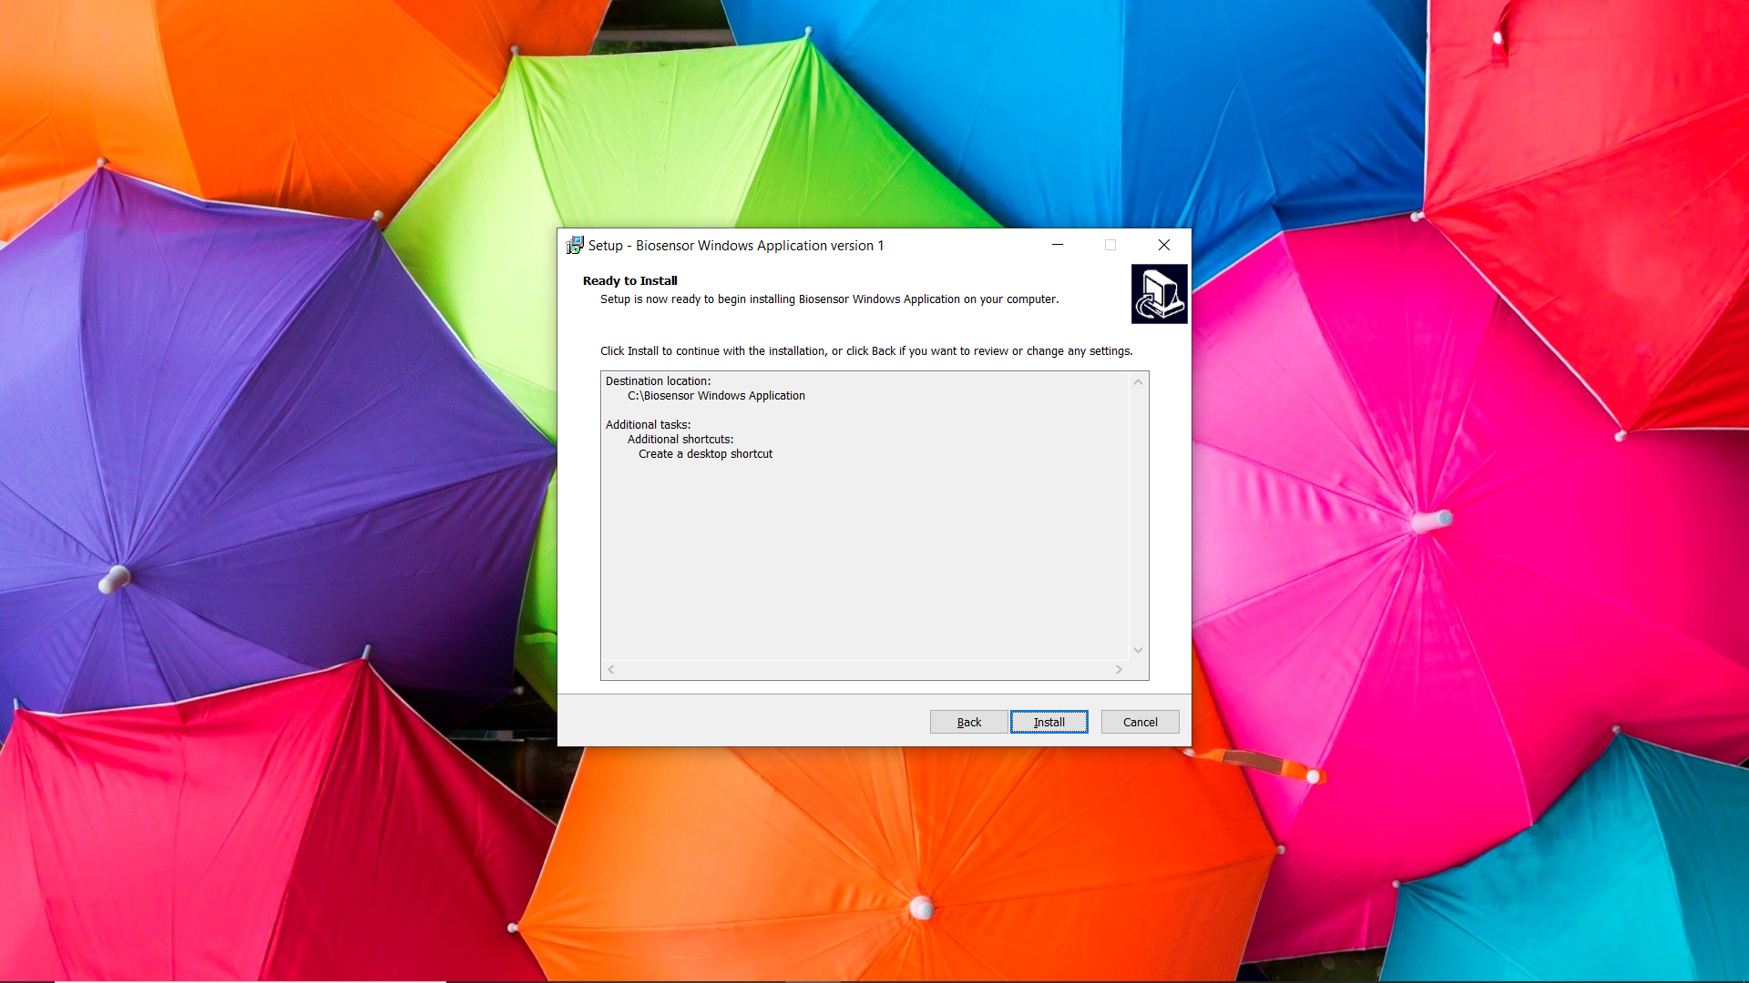

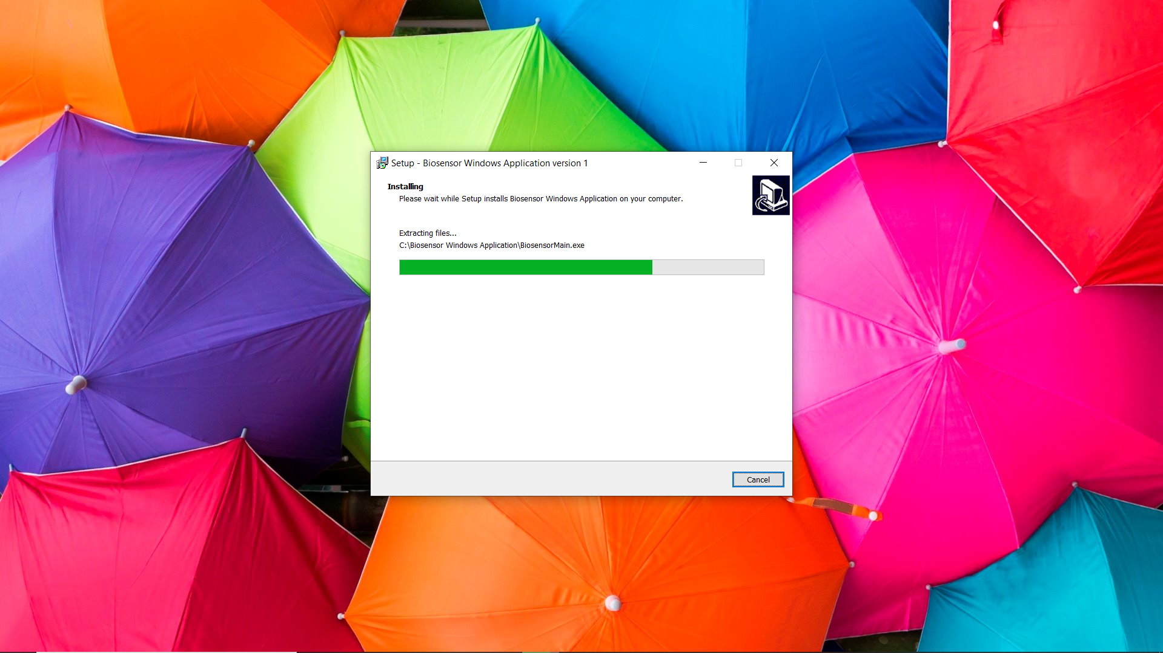

After the installation is finished, the shortcuts will be available in the desktop.



*Important features and quality of life fixes*

* To uninstall the program, go to the installation location and execute the uninstall00.exe. It will do most of the uninstallation. But it will not remove the data logs. So, if the removal of the entire program is desired, it is recommended to manually delete the data logs.
* If the UI elements are not loaded in properly, try to uninstall the program and re-install via the installer and see if it fixes the issue.
* If the user receives the error “*BiosensorApplication Script has failed to run”,* the application is most likely saved in an administrator folder. There are two methods to resolve the problem, run the application as an administrator or uninstall the program and install it into a non-administrative folder.

# Common issues and fixes

## Raspberry Pi

* *Loading interface freezes up and does not automatically continue within 5 minutes.* 
  + This can occur when the Raspberry Pi does not detect the biosensor appropriately. Please close the application, un-plug, and re-plug the device and try running the application again. If this does not work, leave the biosensors connected to the Raspberry Pi and reboot.
* *After running polarization test, if the option change rload to estimated rload is selected, the user will not be able to change the rload manually until the next acquisition cycle.* 
  + This is less of a fix but more of a tip if, the user wants to change the rload immediately after polarization, the user will have to start a cycle and then modify the settings after.

# Developer’s Guide Tips and Tricks

## Raspberry Pi

* By default, on the Raspberry Pi 3, python3.7 and python 2.7 are installed. When editing this program, make sure python 3.7 is used when testing and debugging.
* When using *LinuxOSinstall.sh.command* located in *OnlineBiosensorMCU/Version 1/Installation files/* to install the Biosensor Application, it automatically installs useful qt-dev tools, which are used to design the .ui files. For example, the “Qt 5 Designer” application can be found in the programming category of the start menu. It is recommended to use the application to design the UI and to load the UI files into the python program in the code.
* When designing scripts, make sure the scripts are set to executable.
* When editing the repository file/folder format, the installation scripts, located in *OnlineBiosensorMCU/Version 1/Installation files*/, and the *runBiosensor.sh* scripts located in *OnlineBiosensorMCU/Version 1/Source files/* will need to be modified. When editing the script files replace every “Source files” keyword with the new location of the script file.

## Windows

* To develop this program on windows, python3.7 or python3.8 and pip installed. Both environments are functional and tested.
* The program was initially designed and programmed in python. However, the final product was an installation file. To do this, the workflow went from functional python file to an executable program and then to an installation executable. This section explains the steps necessary steps to go from a functional python file to an installation file. **Disclaimer**: **At the time of this writing, this is the method that was used, but by no means is it the only method nor the best method. There are many methods to accomplish this. Furthermore, this process should be replicable on the Raspberry Pi but with the current implementation, there was no reason to do so (ie: python to .deb, and then using a bash script to execute the .deb file)**

1. First step is to make sure the python file is functional. The important thing here is to make sure the file pointers are dynamic. If static file paths are used to locate output files and resources files, switching from python to exe or between different operating systems will be difficult. This can be done by using pathlib.Path() method from pathlib. Look at this link for more information <https://docs.python.org/3/library/pathlib.html>
2. To convert the python file to an executable file, a python package called PyInstaller was used. It is used via command line, so if the user is not familiar with command line, the user may also try using the “auto-to-py-exe” package instead. Make sure either package is installed with the current python version. A good resource to look at before moving on: <https://pyinstaller.readthedocs.io/en/stable/>.

In fact, it is preferred if the user relied on the pyinstaller documentation over the documentation below. It will be more up-to-date and more reliable. The documentation below should be used as a small guide vs the public pyinstaller documentation.

Another thing, try not to run pyinstaller on the newest version of python 3.8.x. It will tend to cause issues since now every package updates immediately after a new version of python.

Moving on, open the command line and navigate to the location of the python file in the as shown in the example below.

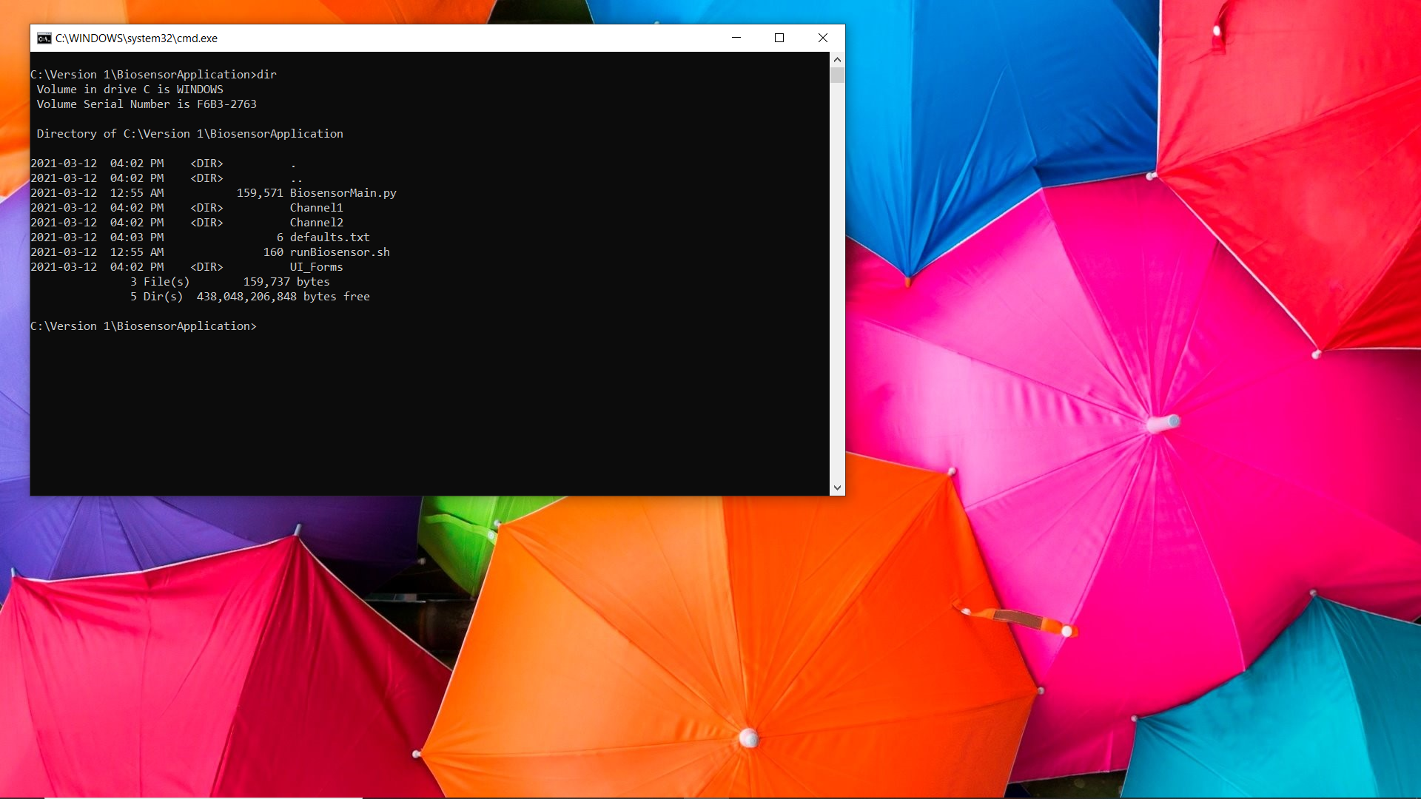

Run the command “*pyinstaller BiosensorMain.py --onefile –windowed*”. This operation will take a few moments. The --onefile argument specifies to create a one-file bundled executable and the --windowed argument specifies that the program will not have a console window. **For testing purposes, do not use --windowed so the errors are visible in the console window.**

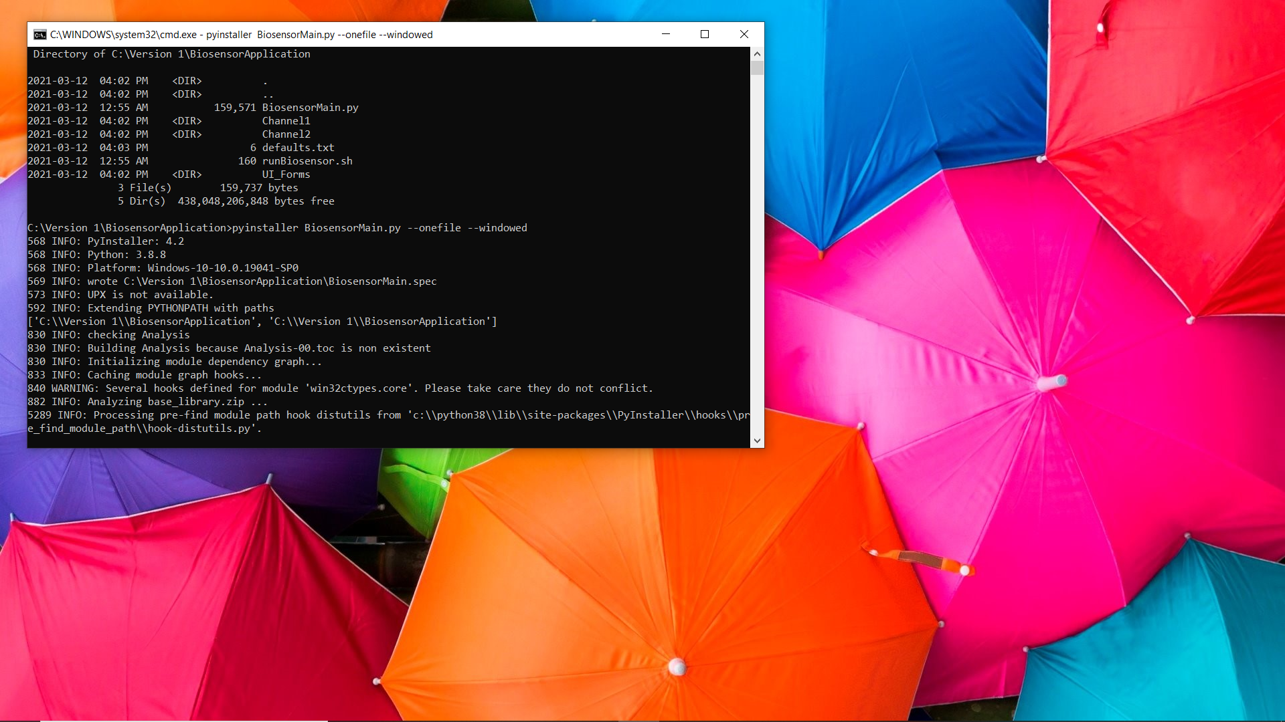

If you look inside the dist folder and the executable should be visible. Before debugging the executable, make sure both the .py file and the newly created .spec file is visible.

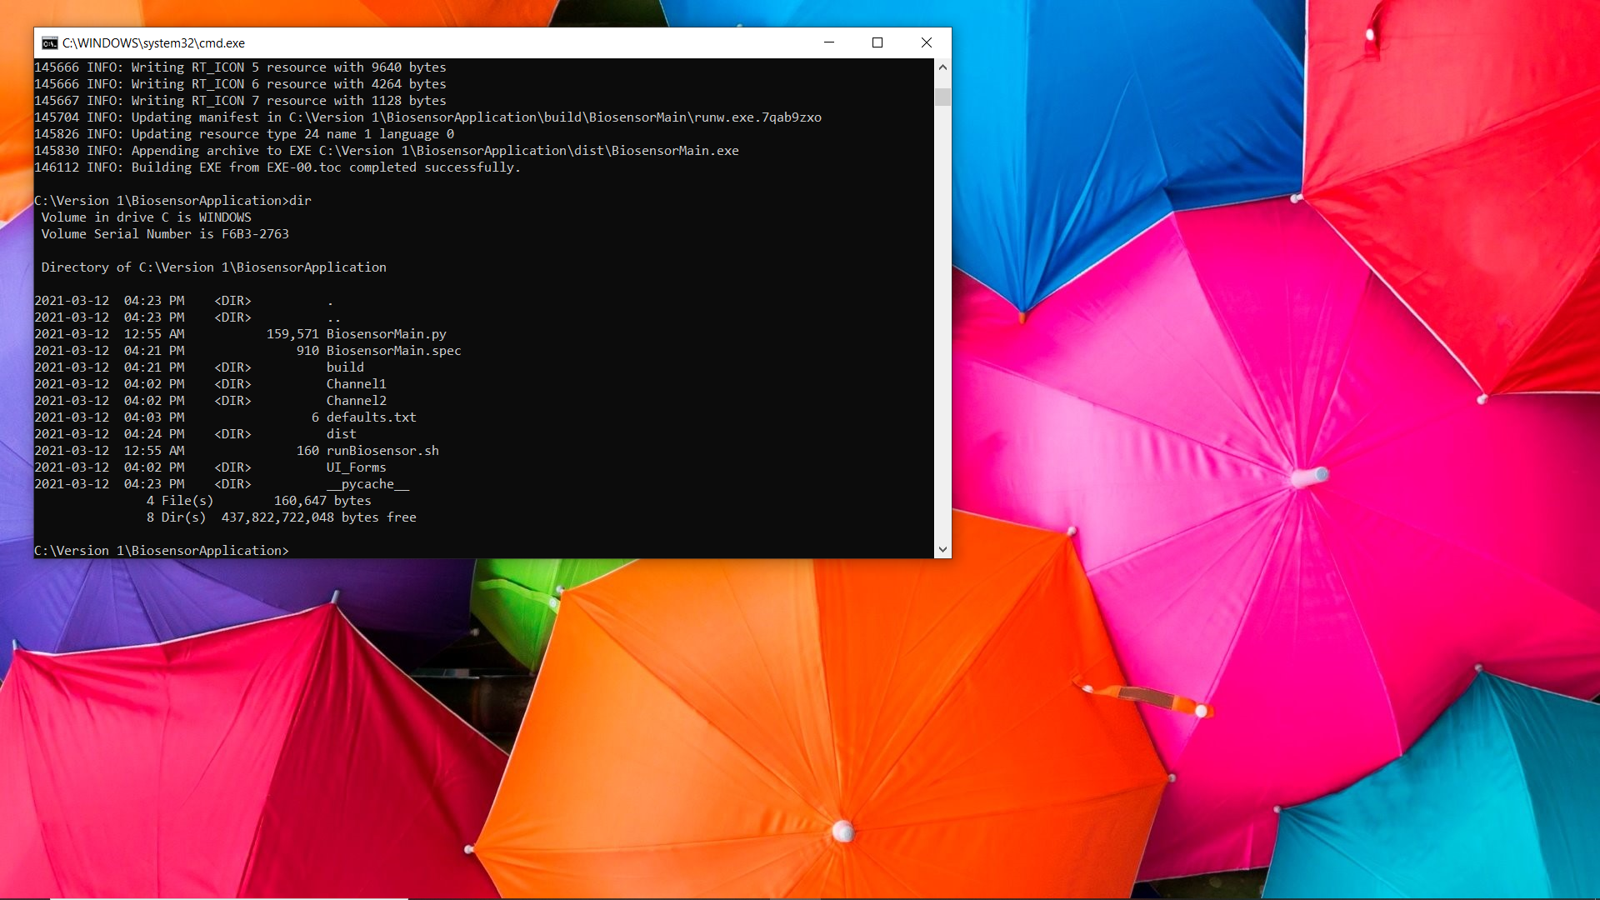

Now UI resources must be added exe. There are two methods to accomplish this, via command line or by editing the spec file. To edit via command line, you enter “*pyinstaller -F --add-data "path/to/UI_Forms;/UI_Forms" BiosensorMain.spec”*, where *path/to/* is your literal path. The other method involves directly editing the .spec file. To add the data folder, I edited the .spec file using notepad. In the datas = [], add *("path\\to\\UI_Forms", "\\UI_Forms")* between the square brackets as shown below. **Read the following document if there are issues:** [**https://pyinstaller.readthedocs.io/en/stable/spec-files.html**](https://pyinstaller.readthedocs.io/en/stable/spec-files.html)

Then, in the terminal run *pyinstaller BiosensorMain.spec* to re-compile the executable.

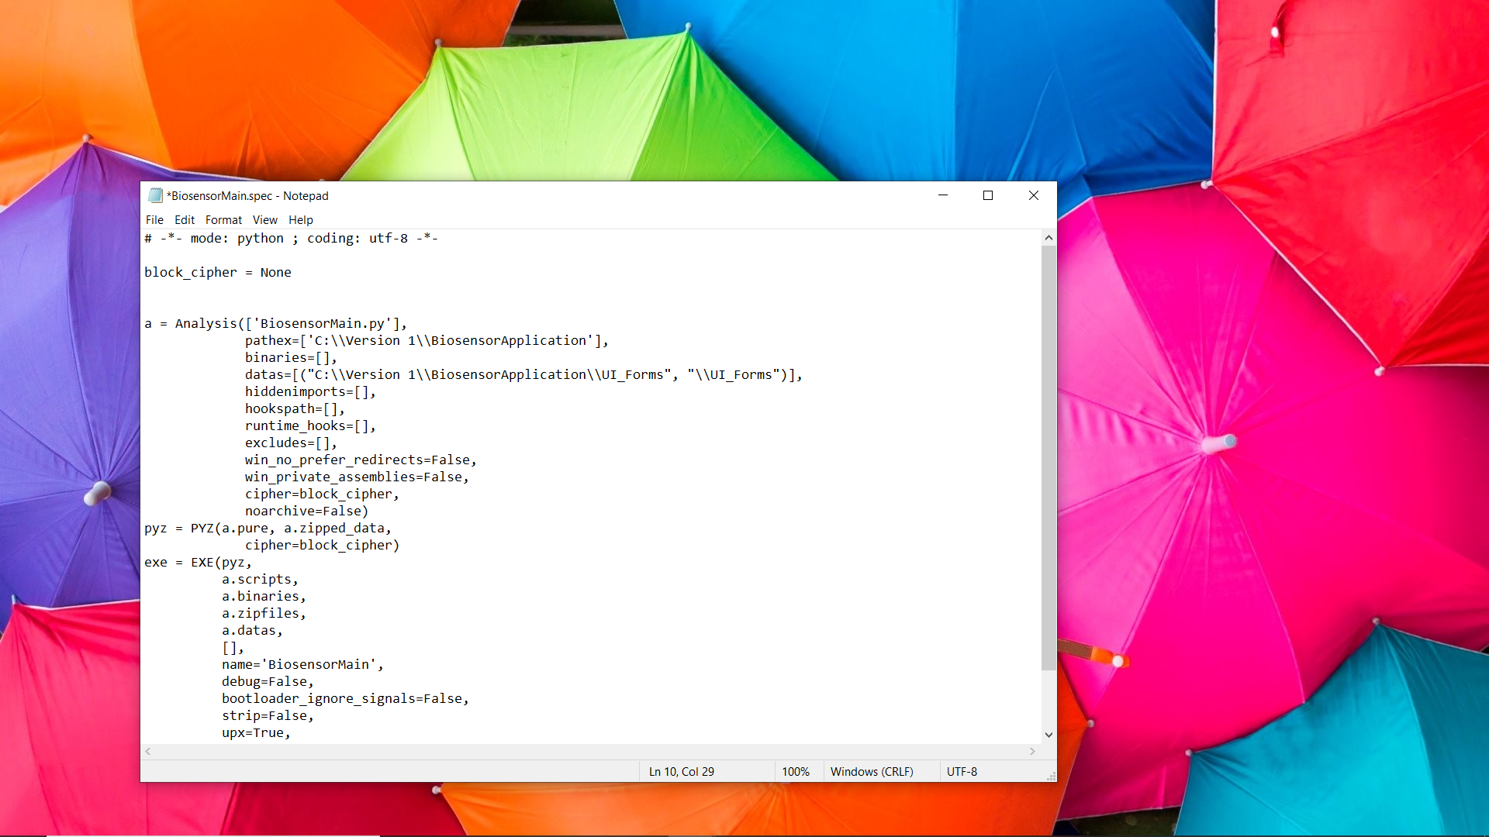

Now begins the debugging process for the exe. PyInstaller tends to fail to import certain modules when it packages everything. To find the missing modules the user can either navigate to the build directory and look through “warn-BiosensorMain.txt” to find what is missing, or the user could look at the terminal output when the command *pyinstaller BiosensorMain.py* was run and look for the keyword hidden import not found. Once found, they must be added to the hiddenimports. There are two methods to accomplish this, via command line or by editing the spec file. For more information, please look at the documentation above, but it is in a similar format as adding data. This is what my spec file looked like at the end.

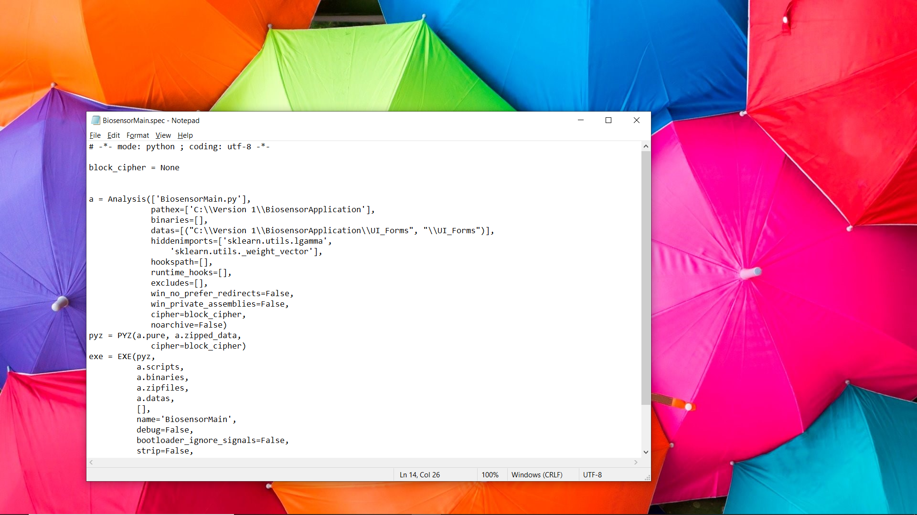

Lastly, make sure to add the program icon to the executable. The path to your ico file will be different depending on where you are installing. Run *pyinstaller BiosensorMain.spec* again after saving the .spec file. This was my final .spec file.

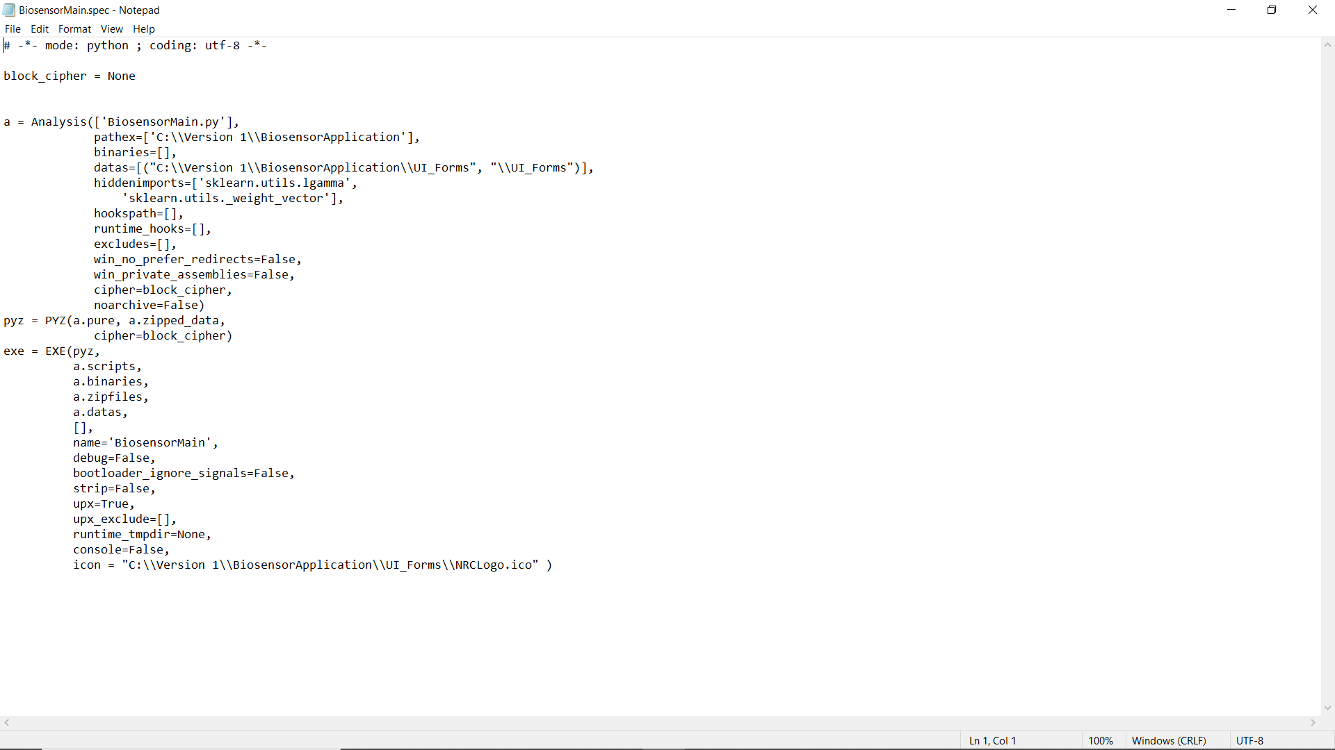

**Note: As a final check, look at the executable in the dist folder. Check if the icon of the program has been updated. If not, copy the entire folder, and paste it into another location. See if the icon of your executable has been updated. If so, that means that icon has been set-up appropriately. Please remember the location of the dist folder. After, make sure to test the executable at least once to create the folders as shown below.**

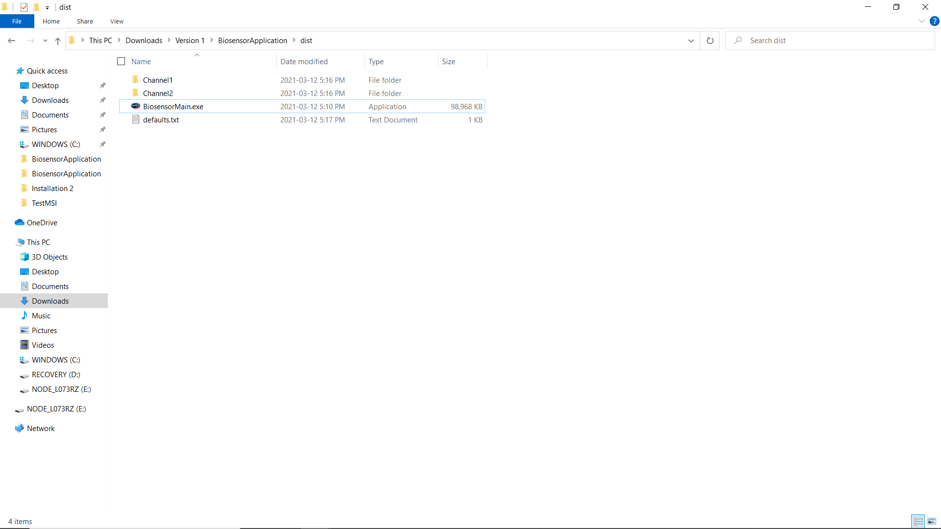

1. Now, the executable needs to be packaged into the installation files. Depending on the user’s familiarity with windows installers (.msi) files this may be very straightforward. If the .msi route was chosen, Advanced Installer or MSI Wrapper could be used. In the documentation, Inno Setup was used due to its simplicity. Whichever option is chosen, make sure you have that product installed. Since Inno Setup was used, this documentation will be referring to that. The following websites were used as a reference point: <https://jrsoftware.org/isinfo.php> and <https://www.youtube.com/watch?v=Y9Ovo2XJHDs>.

After reading the documentation, the user can develop the script using the provided Inno setup script, *BiosensorInstallationScript.iss* located in *OnlineBiosensorMCU/Version 1/Installation files/Other files/*.

**NOTE:** **Before I started working on the script, I cleaned up the folder that contained my exe.**



**Make sure it looks like the above.**